Grain Matching for EBSD Maps Stitching with Graph Connectivity
and GATv2 Comparison
Abstract:
Accurately stitching multiple electron backscatter diffraction maps (EBSD maps) is incredibly hard on older manual scanning electron microscopes (SEM). A heavily deformed sample, such as a cold-rolled aluminum sample, where the grains are incredibly small. It’s almost impossible to stitch them together in the vertical (Y) direction accurately. In the horizontal (X) direction, approaches like counting steps would work with near-perfect precision, with low sample drift, charge distortion, and other uncertainties. In this paper, a matching process based on crystallography, geometry, and confidence index (CI) is proposed for EBSD stitching. Grain orientations are represented in $g∈ SO(3)$ space. $F(g^{'}, (g,r))$ represents local interactions. By comparing grains across tiles (a small section of EBSD maps) based on orientation, spatial proximity, and CI. Then incorporated into a stitched microstructure.
This method is then compared against a neural network and a hybrid gated fusion approach. The graph attention network (GATv2) was chosen here because the nature of EBSD stitching can be simplified to a graph problem. The grains can be represented as nodes, and the relationships between nodes are captured through edges. Attention mechanisms allow weighting features adaptively. Results show that the physics-based approach achieved a higher matching accuracy and a near-zero false match rate. Compare to the machine learning model. Limited data seems to have contributed the most to the high. Although gated fusion improved stability, it still didn’t outperform the physics-based approach. These demonstrate that EBSD stitching is constrained by the underlying microstructure statistics. For now, rule-based methods can easily outperform machine learning. The proposed physics-based approach provides the most efficient approach for EBSD map reconstruction. In the future, with enough data, hybrid gated fusion might provide an easier approach to a more complex microstructure.
Introduction:
Electron backscatter diffraction is a technique for characterizing crystal orientation and microstructural features. Reconstructing large area microsaurs often requires stitching multiple EBSD scans acquired sequentially across the sample while overlapping.
Accurately stitching EBSD maps is very challenging due to geometric distortion during scanning. Without access to automated SEM or proprietary software. The samples are usually tiled at 70 degrees, which would cause projection-based distortion, especially in the vertical direction. Other sources of error, such as charging, carbon deposit, and other artifacts, could further complicate the task of stitching EBSD maps together. While there are numerous approaches to approximate alignment with known x steps. Vertical alignment is significantly harder, due to distortions and measurement uncertainty.
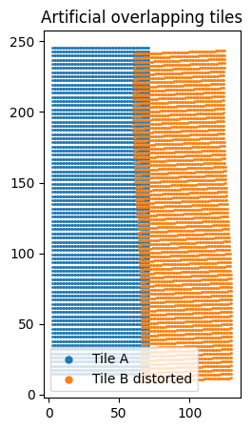
Figure 1: Artificial EBSD Tile Overlap Illustrating Geometric Distortion
Figure 1 demonstrates the challenge of aligning two tiles, especially in the vertical direction. Here, artificial distortion is added due to the lack of geometry and raster pattern of the SEM. Although the underlying microstructure is continuous. Geometry and artifact distortion caused misalignment between the two regions. Making it almost impossible to match across with direct spatial approaches. As a result, a stable and repeatable framework to identify the grain correspondences across two different section maps is required for accurate stitching.
In this paper, an approach based on grains’ crystallographic consistency, spatial continuity, and measurement is proposed for EBSD map stitching. To assess how effective the proposed approach is. Its performance is then compared to a graph attention network (GATv2) and a hybrid gated fusion method. While GATv2 provides a big amount of flexibility, results show that the physics-based approach clearly achieves higher accuracy and improved robustness under limited data. These findings suggest that for EBSD stitching to become an efficient and reliable solution. Approaches have to strongly rely on underlying physical constraints and rule-based approaches.
Theory:

Orientation Representation:
The microstructure can be defined in orientation space as:
$$g∈ SO(3)$$
For planar, the rotation can be defined as:
$$R\left(θ\right)=\left|\begin{matrix}\cos{θ} & -\sin{θ} \\ \sin{θ} & \cos{θ}\end{matrix}\right|$$
Where $θ$ represents the orientation angle.

Misorientation
The relative orientation between two grains is defined as:
$$Δ g = g_{A}g_{B}^{-1}$$
The misorientation between grain A and grain B can be defined with the function above.

Spatial Representation
Each point in the EBSD map has a unique spatial coordinate,
$$x∈ R^{2}$$
The spatial relationship between two points is defined by:
$$r = x' - x$$

Orientation Distribution Function
The statistical distribution of orientations from the 2015 Acta Materialia paper:
$$A\left(g\right)=lim_{d→0 }\frac{v_{f}\left(R_{d}\right)}{∫\left(R_{d}\right)dg}$$
This function can be normalized to:
$$∫ A(g) dg = 1$$

Nearest-Neighbor Orientation Correlation
To define spatial correlations between orientations, the nearest-neighbor conditional orientation correlation function in the 2015 Acta Materialia paper is used:
$$F(g^{'}∣ (g,r))$$
The function can also be normalized:
$$∫ F(g^{'}∣(g,r)) dg' = 1$$
Methodology:

Data Preparation
EBSD datasets are in the format of “.ang” and contain spatial coordinates, crystallographic orientations, and confidence index (CI) values for each measurement point. For simplicity, the parent EBSD maps are divided into overlapping tiles to simulate multi-scan acquisition.
By group pixel in the grains based on orientation similarity, grains can then be segmented. For each grain, the centroid position $x_{i}$, representative orientation $g_{i}$, and average confidence index $CI_{i}$ can be extracted.

Pre Pair Generation
Pre-pair grain correspondences are generated across overlapping regions between adjacent tile maps. For tiles A and B, grains located within the overlap region can be indexed. For each grain, $i∈ A,$ a set of pre-pair grains $j∈ B$is chosen based on spatial data:
$$r_{ij}=x_{j} -x_{i}$$
Only grain pairs within a predefined spatial distance apart are considered as potential matches.
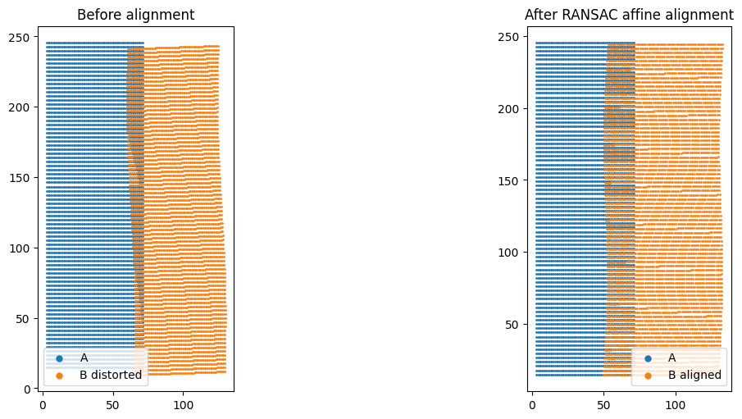
Figure 2: Before vs After RANSAC alignment

Physics-Based Matching
Correspondence is defined based on crystallographic consistency, spatial continuity, and measurement reliability.
The relative orientation between grains is defined as:
$$Δ g = g_{A}g_{B}^{-1}$$
Pre-paired grains can be matched only if they satisfy the conditions:
- small relative orientation difference
- spatial proximity within the overlap region
- sufficient confidence index

Graph Representation – ML model prep
The EBSD microstructure is defined as:
$$G = (V, E)$$
For the graph attention neural network, every grain corresponds to a node V, and edges E represent adjacency relationships within a tile. This representation enables consistent handling of local neighborhood structure and supports comparison with graph-based learning models.

GATv2 Model
A graph attention network (GATv2) is used here to learn grain correspondences. The model takes grain features as input, including orientation, spatial position, and confidence index. Attention mechanisms assign weights to neighboring nodes, allowing the model to adaptively prioritize relevant grain relationships.
The model is trained using labeled grain correspondences generated from synthetic tile splits. Training is performed on tiles derived from one parent dataset, while evaluation is conducted on a separate dataset to assess generalization.

Hybrid Gated Fusion
A hybrid approach is used by combining the physics-based approach with GATv2 predictions. A gating mechanism is used to control the contribution of each method, prioritizing physically consistent matches while allowing learned predictions to influence ambiguous cases.

Evaluation Metrics
The performance of each method is evaluated using both spatial and crystallographic metrics, including:
- coordinate root mean square error (RMSE)
- nearest-neighbor coordinate error
- fraction of matches within spatial tolerance
- mean misorientation between matched grains
These metrics assess the accuracy of both geometric alignment and crystallographic consistency in the stitched microstructure.
Results:
The proposed stitching approach was evaluated on EBSD tile pairs using both spatial and crystallographic theory. Figure 3 presents the reconstructed EBSD maps, including image quality (IQ), confidence index (CI), orientation visualization, and seam region identification. The stitched microstructure shows continuity across the overlap region; there are no obvious discontinuities in the grain structure.
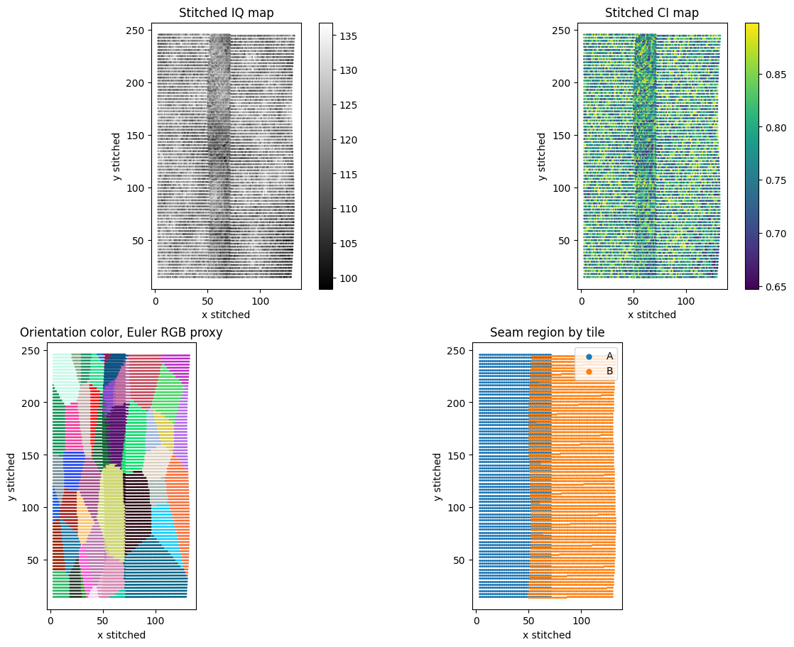
Figure 3: Reconstructed EBSD Showing IQ, CI, and Orientation Mapping
By comparing the methods quantitatively shown in Figure 4. The physics-based approach achieves the highest performance, with an F1 score of approximately 0.27 and a near-zero false match rate. In contrast, the GATv2 model shows significantly lower performance, failing to identify correct grain correspondences in most cases. The hybrid gated fusion approach improves over the standalone GATv2 model but does not outperform the physics-based method due to the limited training data set. The result might significantly improve with a larger dataset. But the question of how big a data set is or whether it has to be trained for a specific grain structure every time still isn’t answered.
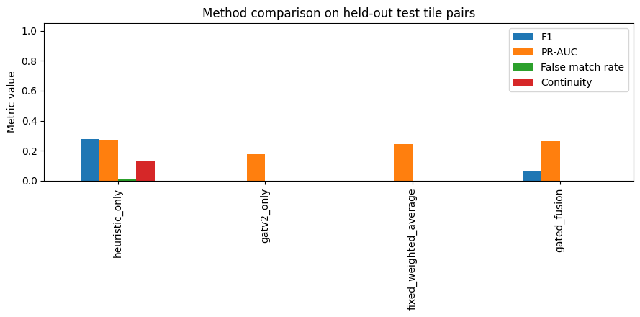
Figure 4: performance comparison when tiles are stitched down and right
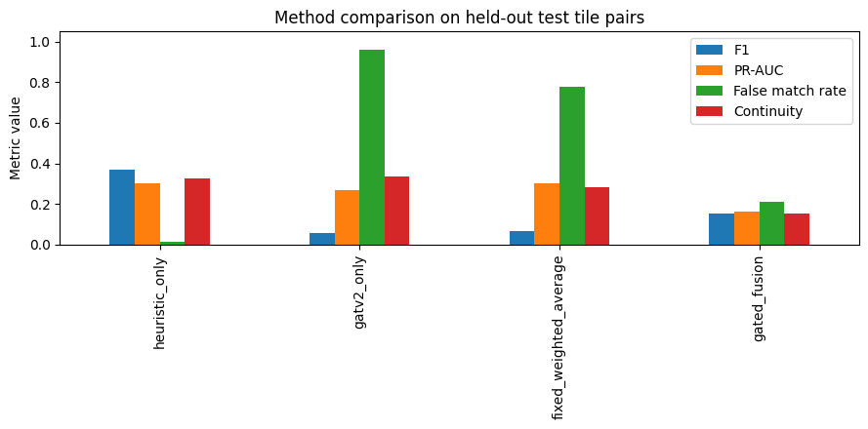
Figure 4: performance comparison when tiles are stitched only right

Evaluation on a separate parent dataset further highlights differences in performance. While the physics-based method maintains low misorientation error, indicating correct crystallographic matching, the hybrid approach exhibits large spatial errors. The model is incredibly good at pointing out no match, but horrible at finding true match
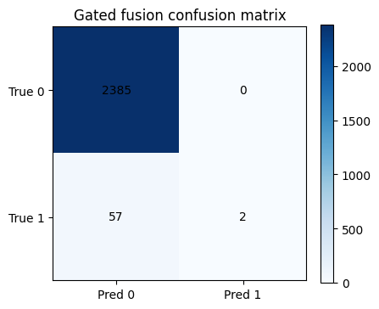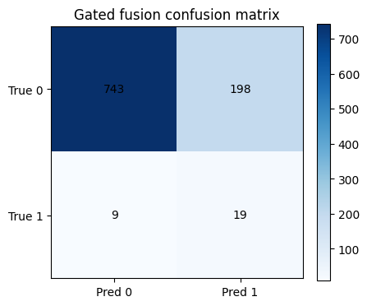
Figure 5: Confusion matrix
These results indicate that the proposed physics-based approach provides more reliable grain correspondence and spatial reconstruction compared to data-driven alternatives under limited data conditions.
Discussion:
The results showed that EBSD stitching is strongly constrained by microstructure physics such as crystallographic and spatial relationships. The physics-based approach performs well because it is directly based on these constraints through orientation consistency, spatial proximity, and confidence index filtering.
Although the GATv2 model should perform really well in theory for graph-structured data such as EBSD maps, its performance is heavily limited by the amount of training data available and the inherent structure of the sample. The model struggles to generalize beyond the training dataset, causing a poor matching accuracy and unstable predictions. This shows that the learning-based approach is unable to fully capture the physical constraints governing equations.
The hybrid gated fusion approach partially improves stability by incorporating physics-based information, but it still fails to provide an accurate spatial reconstruction. The large coordinate errors mean that even when orientation matching is reasonable, the geometric alignment remains very sensitive to insufficient constraints and a lack of training data.
The theme throughout is that misorientation error remains relatively low even in cases where spatial reconstruction fails. This indicates that crystallographic matching alone is not enough for accurate stitching and must be combined with robust geometric alignment methods. Therefore, the primary limitation in EBSD stitching lies not in identifying grain identity, but in accurately reconstructing spatial relationships under distortion.
Overall, the results suggest that physics-based approaches are way more effective than machine learning models for EBSD stitching in data-limited scenarios. The strong constraints introduced by crystallography and spatial continuity reduce the solution enough that rule-based methods can easily outperform more complex models.
Conclusion:
In this paper, a physics-based grain matching framework for EBSD map stitching was developed using crystallographic consistency, spatial proximity, and confidence index constraints. The method was compared with a graph attention network (GATv2) and a hybrid gated fusion approach.
Results show that the proposed method achieves better matching accuracy and improved stability compared to data-driven models. While the GATv2 model provides a flexible framework for learning grain relationships, its performance is limited by a lack of training data and the strong physical constraints of the problem. The hybrid approach improves stability but does not surpass the physics-based method.

These findings prove that EBSD stitching is fundamentally governed by crystallographic and geometric constraints, and that rule-based methods provide an efficient and reliable solution under practical conditions. Future work may explore hybrid approaches with larger datasets and more advanced geometric correction models to improve performance in complex microstructures.

